Lab 1
Web programming

Name : umar ahad uddin ahmed usmani
Sap : 60199

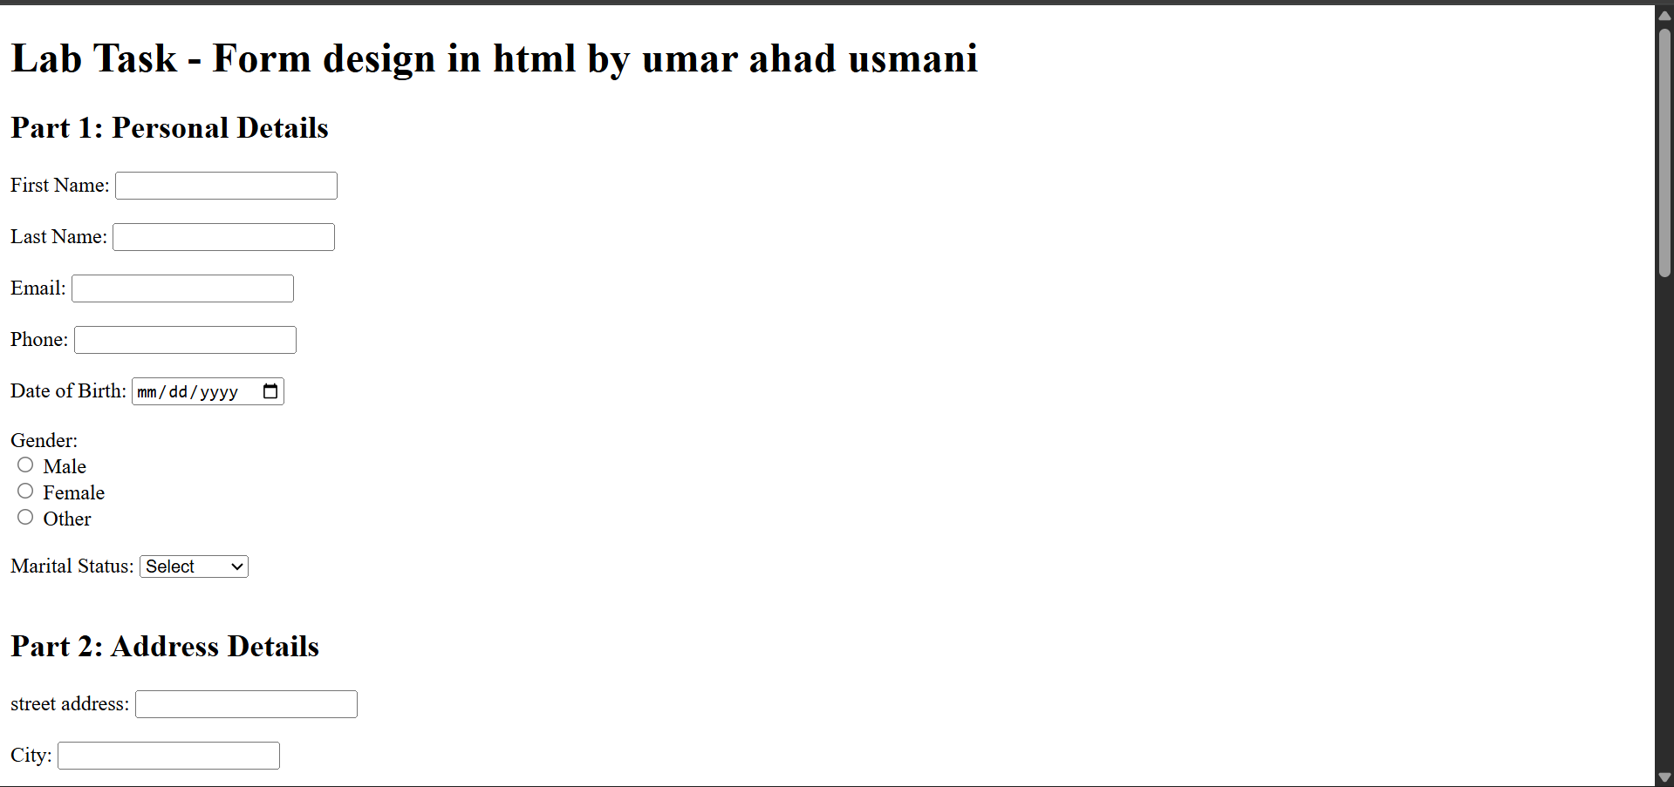

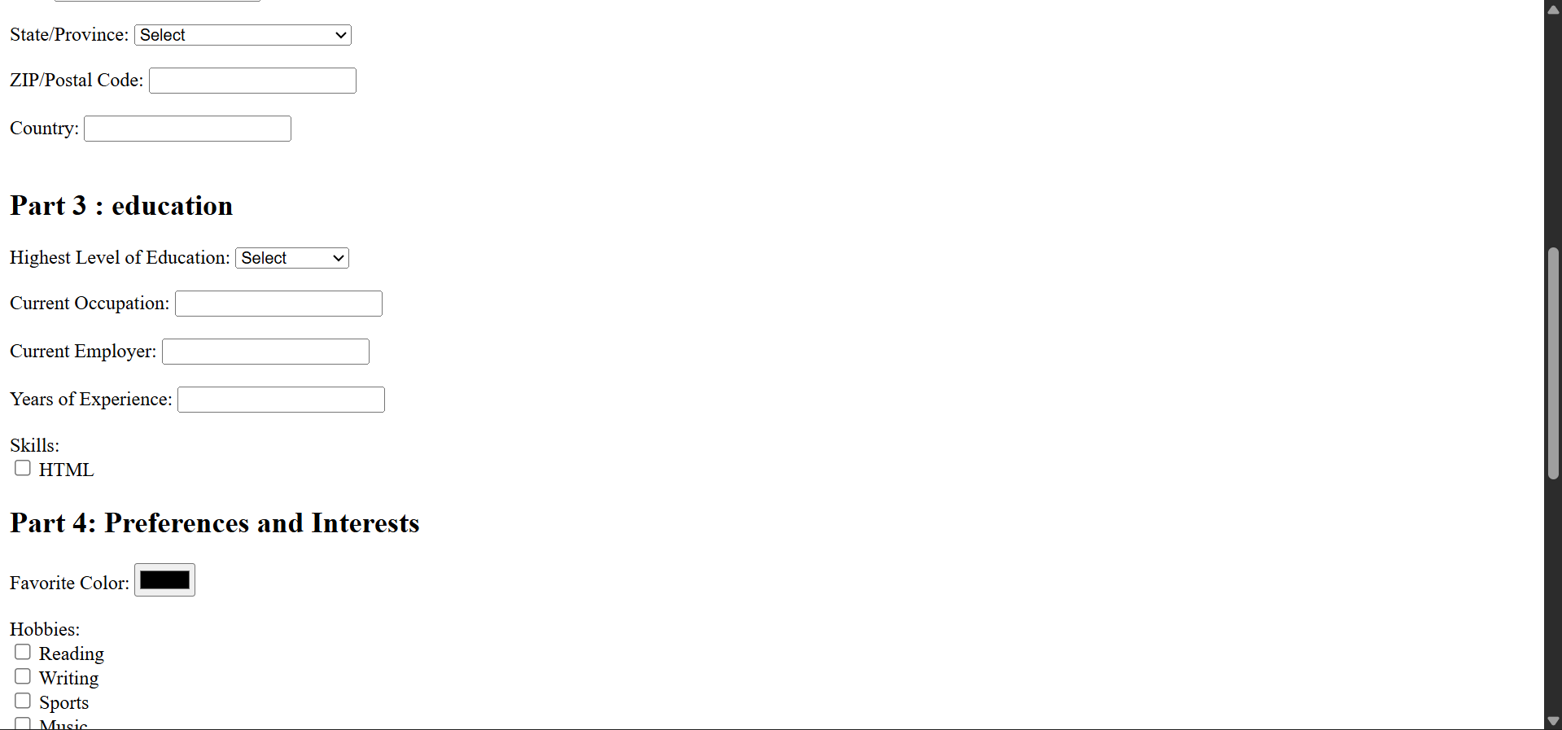

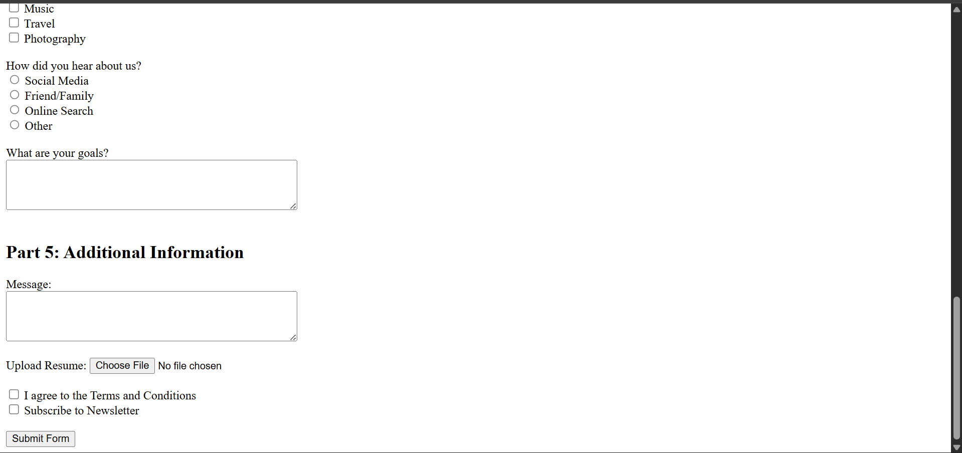

Here is their code <!DOCTYPE html>
<html lang="en">
<head>
<meta charset="UTF-8">
<title> Lab Task - Form design in html by umar ahad usmani </title>
</head>
<body>
<h1>Lab Task - Form design in html by umar ahad usmani</h1>
<form>
<h2>Part 1: Personal Details</h2>
<label for="first_name">First Name:</label>
<input type="text" id="first_name" name="first_name" required><br><br>

<label for="last_name">Last Name:</label>
<input type="text" id="last_name" name="last_name" required><br><br>

<label for="email">Email:</label>
<input type="email" id="email" name="email" required><br><br>

<label for="phone">Phone:</label>
<input type="tel" id="phone" name="phone" required><br><br>

<label for="dob">Date of Birth:</label>
<input type="date" id="dob" name="dob" required><br><br>

<label>Gender:</label><br>
<input type="radio" name="gender" value="Male"> Male<br>
<input type="radio" name="gender" value="Female"> Female<br>
<input type="radio" name="gender" value="Other"> Other<br><br>
<label>Marital Status:</label>
<select name="marital_status">
<option value="">Select</option>
<option>Single</option>
<option>Married</option>
<option>Divorced</option>
<option>Separated</option>
</select>
<br><br>
<h2>Part 2: Address Details</h2>
<label>street address:</label>
<input type="text" name="street_address"><br><br>

<label>City:</label>
<input type="text" name="city"><br><br>
<label>State/Province:</label>
<select name="state">
<option value="">Select</option>
<option>Punjab</option>
<option>Sindh</option>
<option>Khyber Pakhtunkhwa</option>
<option>Balochistan</option>
<option>Gilgit-Baltistan</option>
<option>Azad Jammu and Kashmir</option>
</select>
<br><br>
<label for="zip">ZIP/Postal Code:</label>
<input type="text" id="zip" name="zip" required><br><br>
<label for="country">Country:</label>
<input type="text" id="country" name="country" required><br><br>
<h2>Part 3 : education</h2>
<label>Highest Level of Education:</label>
<select name="education">
<option value="">Select</option>
<option>High School</option>
<option>Bachelor’s</option>
<option>Master’s</option>
<option>PhD</option>
<option>Other</option>
</select>
<br><br>

<label>Current Occupation:</label>
<input type="text" name="occupation"><br><br>

<label>Current Employer:</label>
<input type="text" name="employer"><br><br>

<label>Years of Experience:</label>
<input type="number" name="experience"><br><br>
<label>Skills:</label><br>
<input type="checkbox" name="skills" value="HTML"> HTML<br>

<h2>Part 4: Preferences and Interests</h2>

<label>Favorite Color:</label>
<input type="color" name="favorite_color"><br><br>

<label>Hobbies:</label><br>
<input type="checkbox" name="hobbies" value="Reading"> Reading<br>
<input type="checkbox" name="hobbies" value="Writing"> Writing<br>
<input type="checkbox" name="hobbies" value="Sports"> Sports<br>
<input type="checkbox" name="hobbies" value="Music"> Music<br>
<input type="checkbox" name="hobbies" value="Travel"> Travel<br>
<input type="checkbox" name="hobbies" value="Photography"> Photography<br><br>

<label>How did you hear about us?</label><br>
<input type="radio" name="heard" value="Social Media"> Social Media<br>
<input type="radio" name="heard" value="Friend/Family"> Friend/Family<br>
<input type="radio" name="heard" value="Online Search"> Online Search<br>
<input type="radio" name="heard" value="Other"> Other<br><br>

<label>What are your goals?</label><br>
<textarea name="goals" rows="4" cols="50"></textarea><br><br>

<h2>Part 5: Additional Information</h2>

<label>Message:</label><br>
<textarea name="message" rows="4" cols="50"></textarea><br><br>

<label>Upload Resume:</label>
<input type="file" name="resume"><br><br>

<input type="checkbox" name="terms"> I agree to the Terms and Conditions<br>
<input type="checkbox" name="newsletter"> Subscribe to Newsletter<br><br>

<input type="submit" value="Submit Form">

</form>
</body>
</html>

